Contents

GIT HUB repository 2

Application Description 2

Packages and Classes 2

Class info 3

Class and Methods 3

Agile Development 4

User Guide 5

Display the files of a directory 5

Creating a file 7

Deleting a File 10

Searching a file 12

Menus 14

# GIT HUB repository

The project has been pushed to the following remote repository:

<https://github.com/stratosg2000/Simplelearn-Phase1-End-Project>

# Application Description

The application is named FileMagic and it includes a welcome message, a main menu and a business submenu. The application provides a) the ability to display the file contents of a user specified directory through main menu and three additional business options in the submenu which include creating a file, deleting a file and searching a file in a user specified directory.

When user is executing the program, he has the ability to perform any set of actions before exiting the program. For example, he can create 2 files of any name in two different directories.

The application guides through the menus to all features and requests from subscriber a) to insert the option for the action he wants to execute, as well as to insert the directory path for displaying the file contents and in business sub menu it additionally requests the filename for which the user desires to either create, delete or search according to his desire.

# Packages and Classes

The application uses the following packages and classes

1. The package **filemagic.com.main** includes **App** class.
2. The package **filemagic.com.util** includes **MainMenu**, **SubMenu** and **Welcome** classes.
3. The package **filemagic.com.service** includes **Service** class

# Class info

The application FileMagic has the following classes:

1. Class **App** includes the main method
2. Class **Welcome** provides the welcome message with the application details.
3. Class **MainMenu** provides the following 3 options of the application.

1: Display the files of a folder in ascending order.

2: Business level operation (for adding, deleting and searching a file).

0: To exit from the app.

1. Class **SubMenu** for presenting the business option of creating, deleting and searching a file

1: To create a file.

2: To delete a file.

3: To search a file.

0: To return to main menu.

1. Class **Service** for implementing the functionality required by the menus, thus it provides the method to display the files of a folder, creating a file, deleting a file and searching a file.

# Class and Methods

Each class provides the below methods:

|  |  |  |  |  |  |
| --- | --- | --- | --- | --- | --- |
|  | App | **Welcome** | **MainMenu** | **SubMenu** | **Service** |
| **Public** | main() | displayWelcome() | displayMainMenu | displaySubMenu() | serviceApp |
| **Private** |  |  | invalidMainMenuOptionMessage()  exitMainMenuMessasge() | invalidMainMenuOptionMessage()  exitSubMenuMessasge() | validateDirectory()  displayFiles()  retrieveFilename()  createFile()  deleteFile()  searchFile() |

# Agile Development

The project was developed under 2 sprints.

* In the first sprint we developed the classes App, Welcome, MainMenu and SubMenu. No functionality was provided and only some indicative messages were printed to console for test purposes.
* In the second sprint it was developed the class service and performed the integration with the rest classes.

# User Guide

This user guide provides a description on how the user can use the application.

## Display the files of a directory

The user needs to select 1 in main menu and provide a valid directory path for which the app will display the files inside. If subscriber provides a wrong path, then the app will inform him about it. If subscriber does not have the correct permissions for the directory, then then an error message will appear.

Valid directory. The App displays the files in ascending order

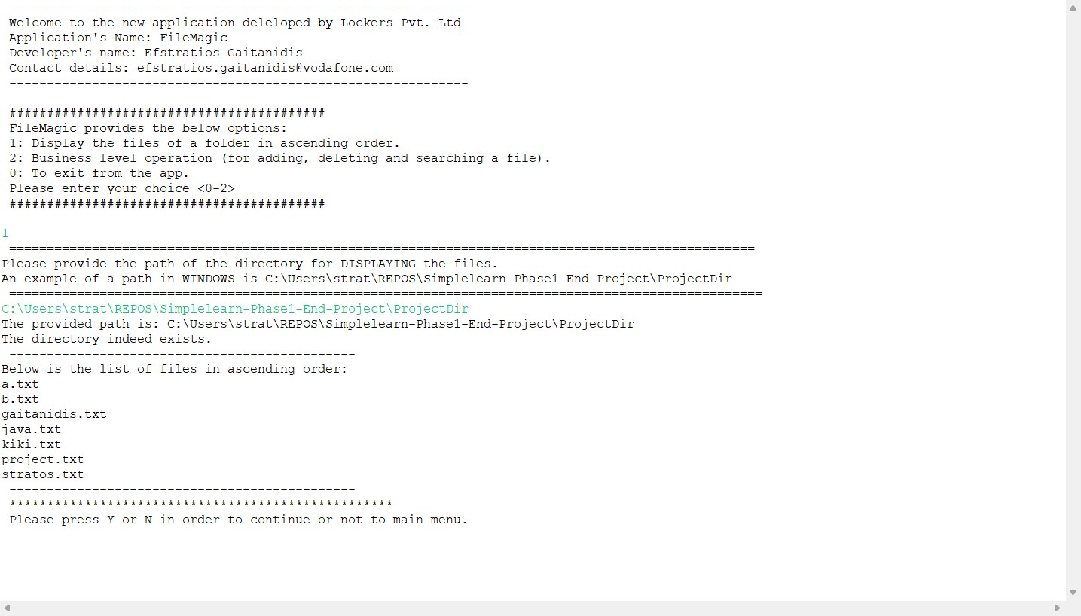

Invalid directory

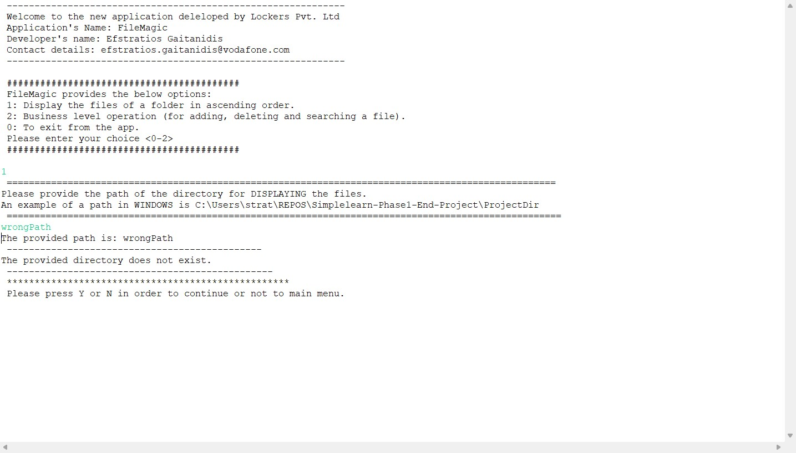

User does not have the Permission

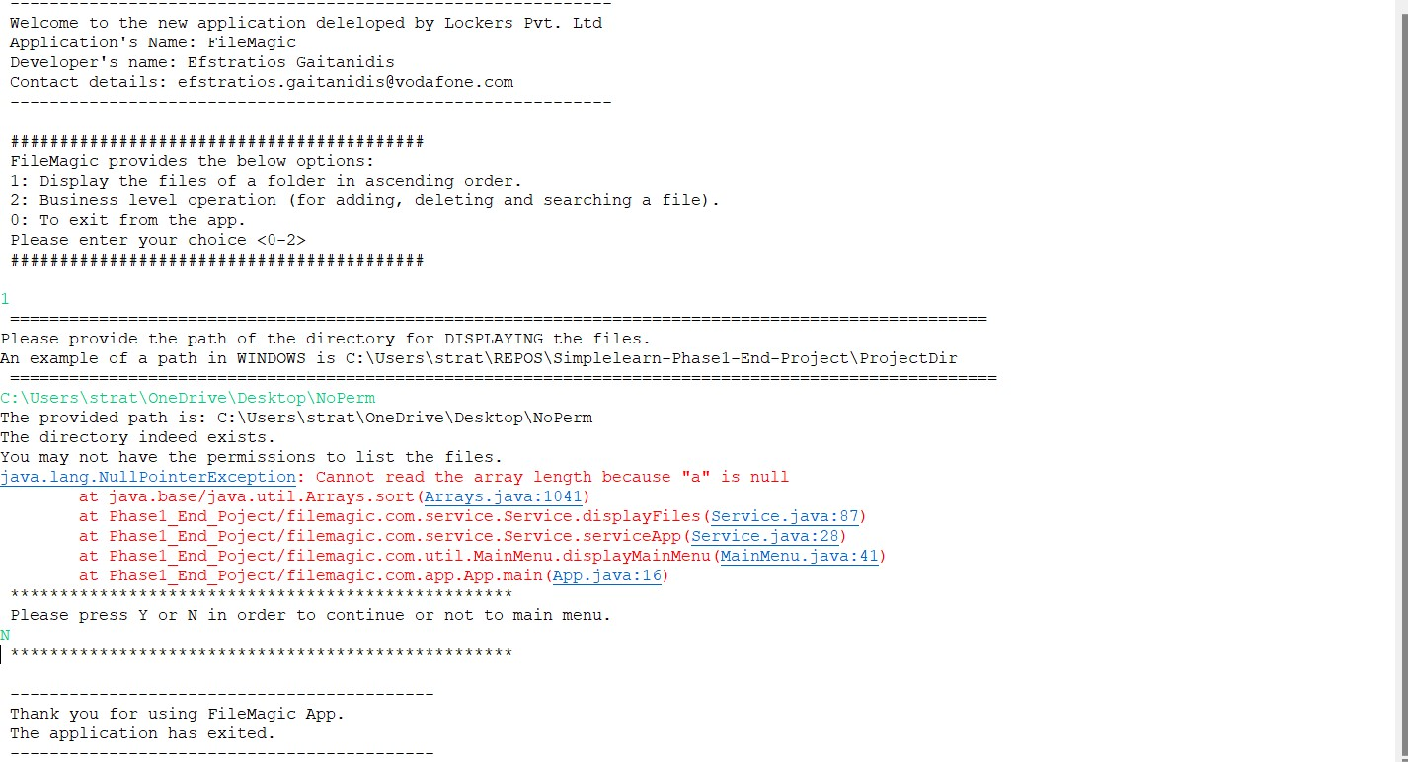

## Creating a file

User needs to needs to select 2 in main menu and the 1 in submenu.

The app will ask the user for a valid directory and the name of the file for the new file.

The app will inform user in the following cases:

* For successful creation
* For incorrect path
* If the file already exists
* If file creation failed due to permission denied.

File Creation

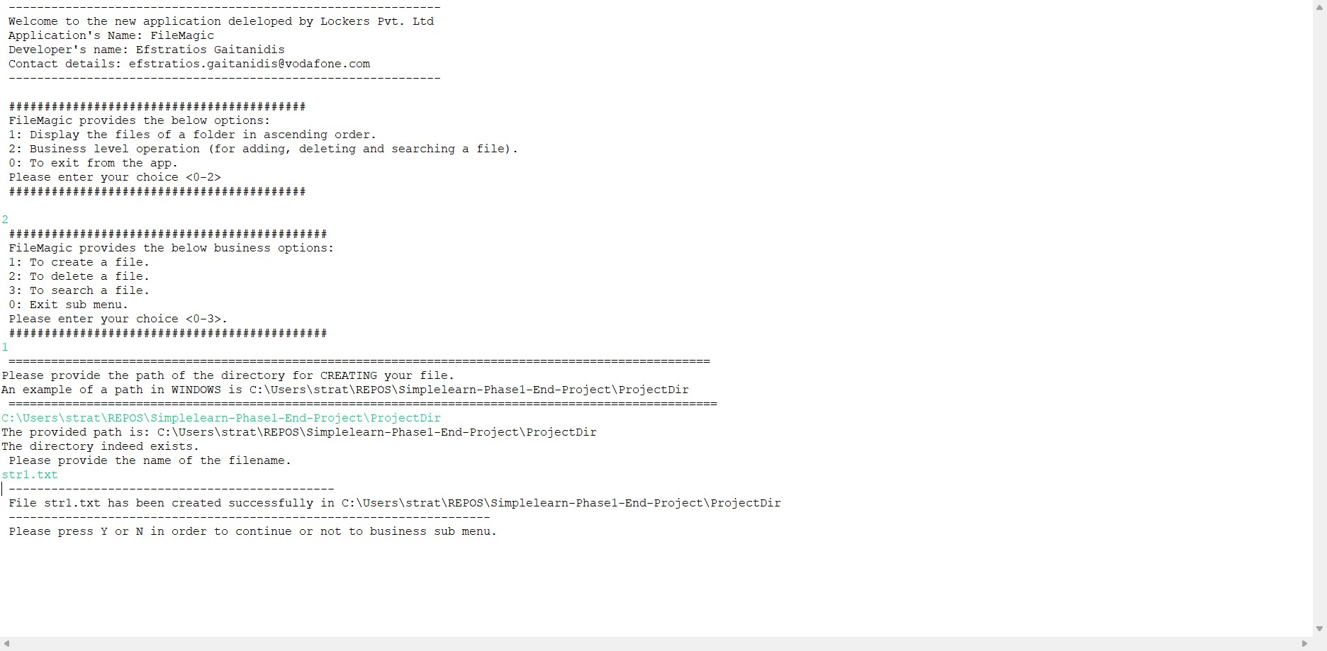

File already exists

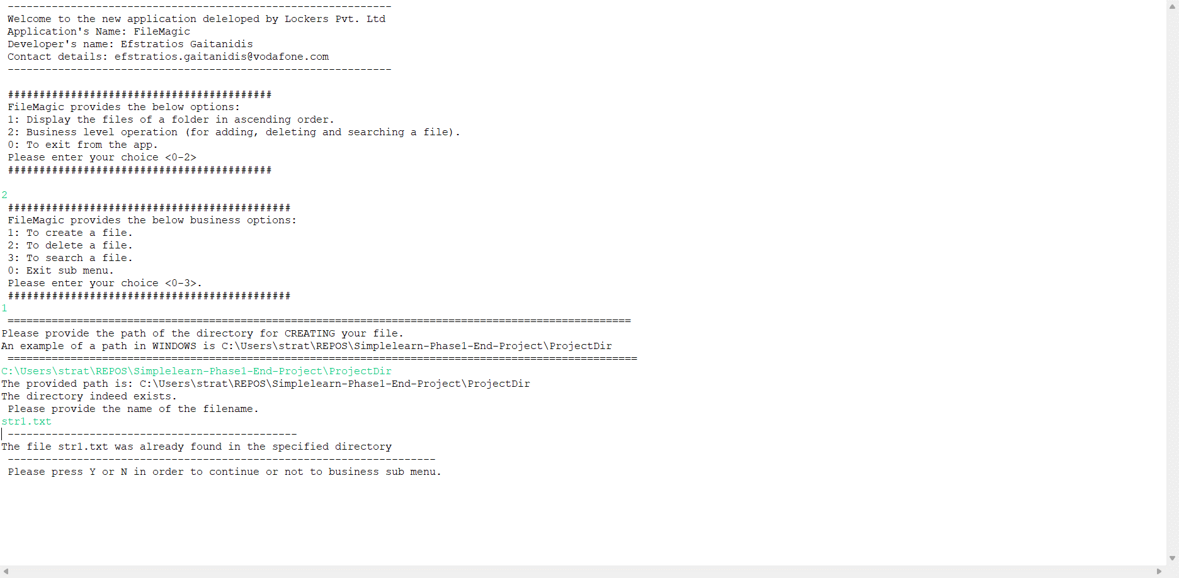

Wrong path

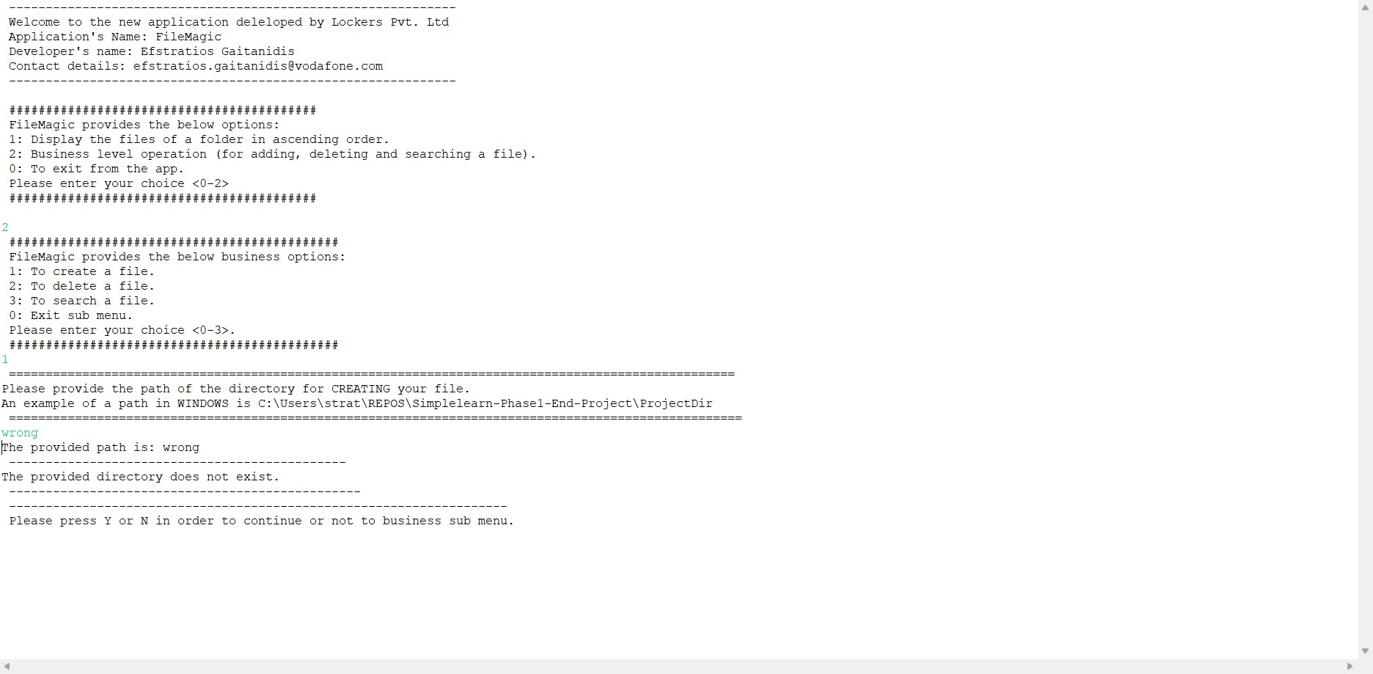

File Creation no Permission

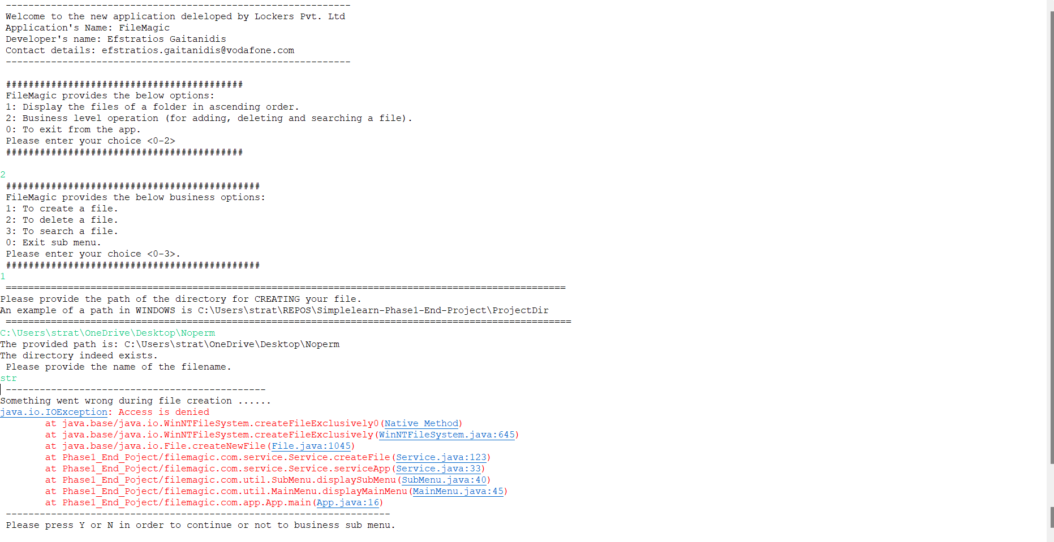

## Deleting a File

User needs to needs to select 2 in main menu and then 2 in submenu.

The app will ask the user for a valid directory and the name of the file to delete.

The user needs to have permission in the specified folder.

Deletion – succeeded

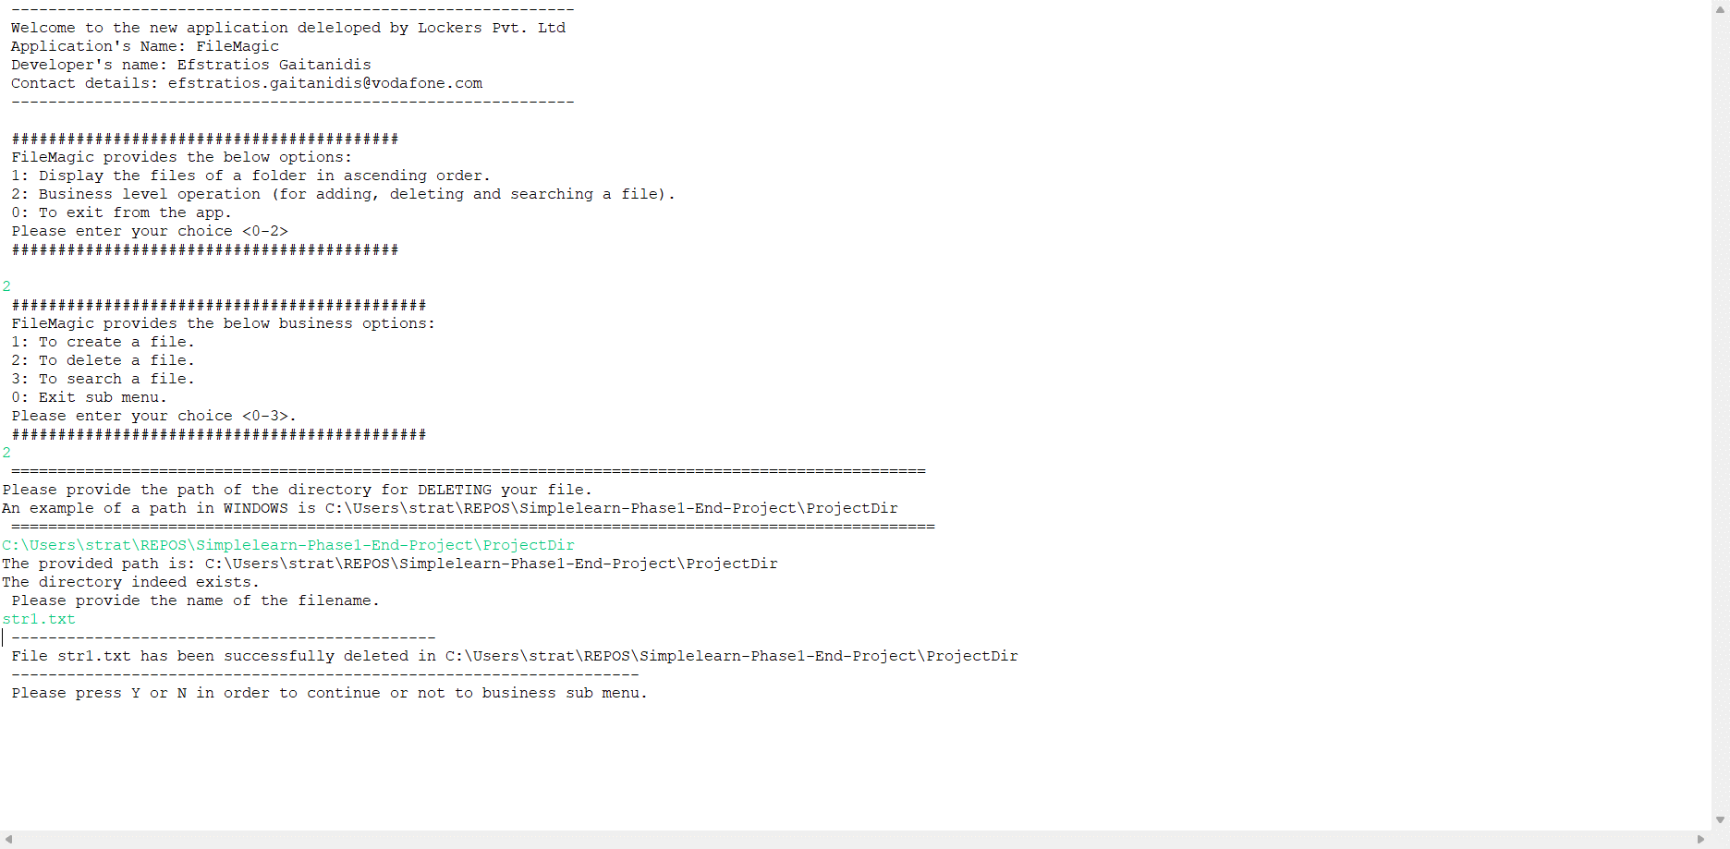

File not Found – or user does not have the correct permissions.

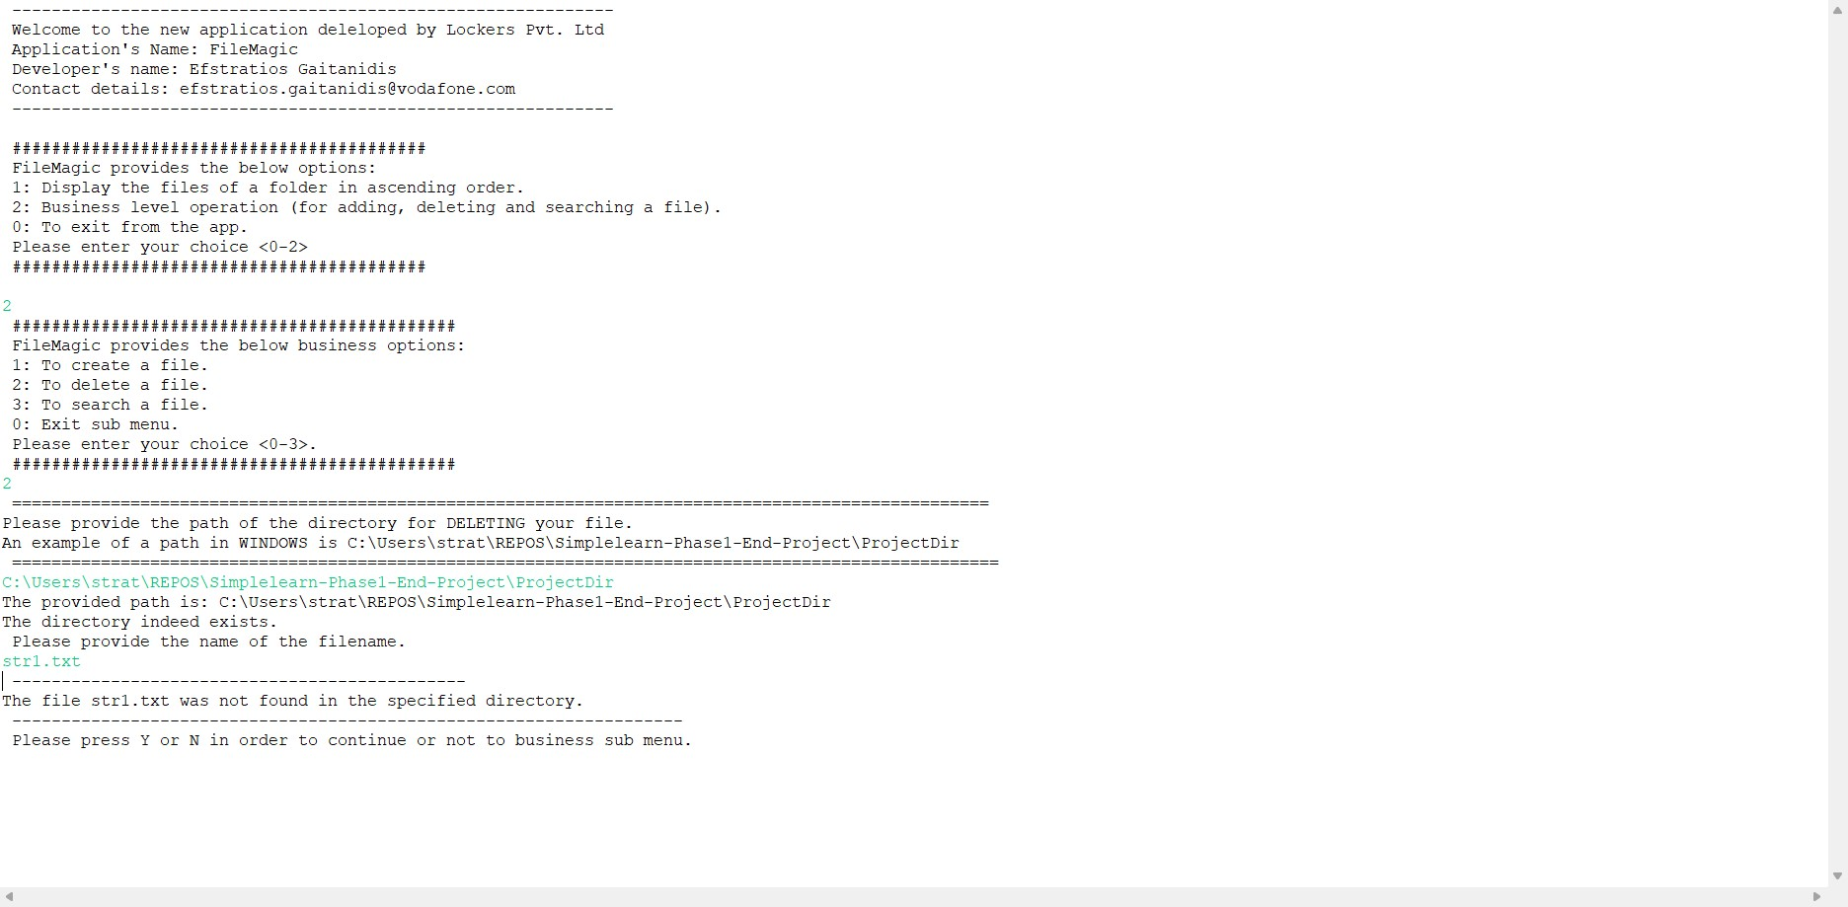

User provided an incorect directory

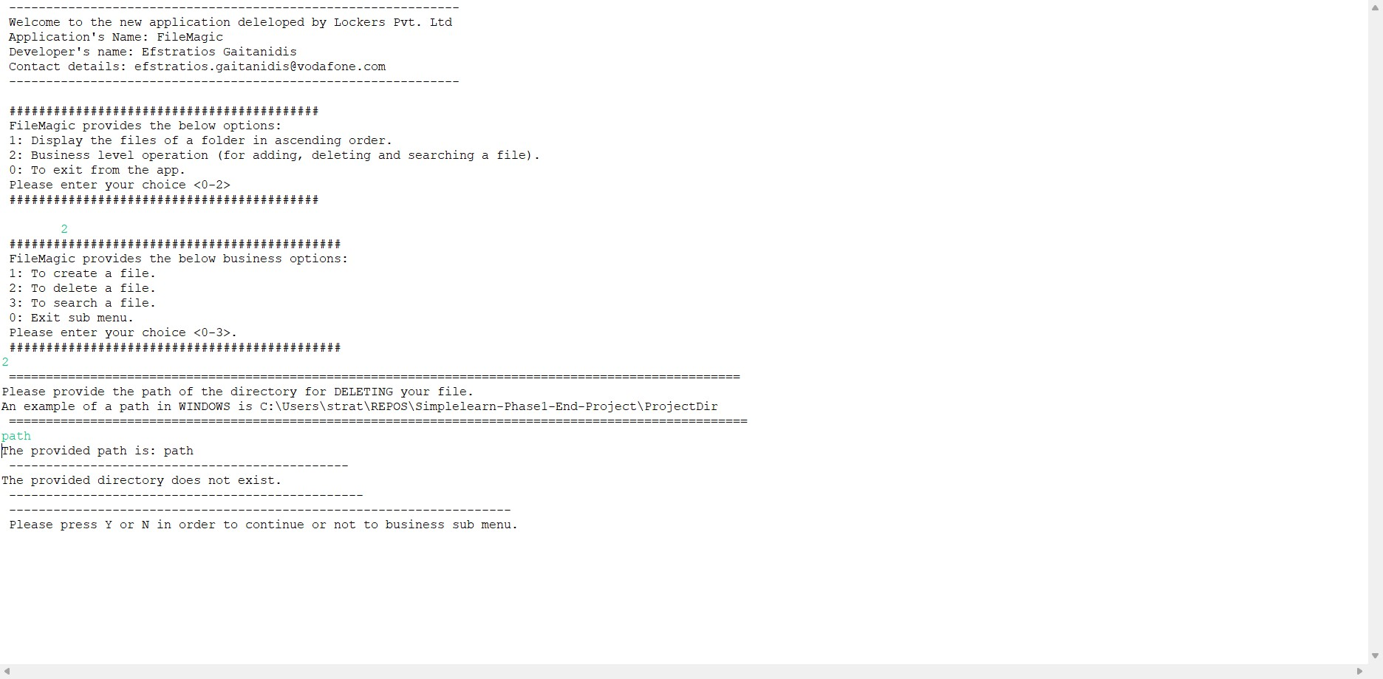

## Searching a file

User needs to press 2 and then 3 and provide a valid directory and the filename to search. The user needs to have the appropriate permissions.

Search – File found

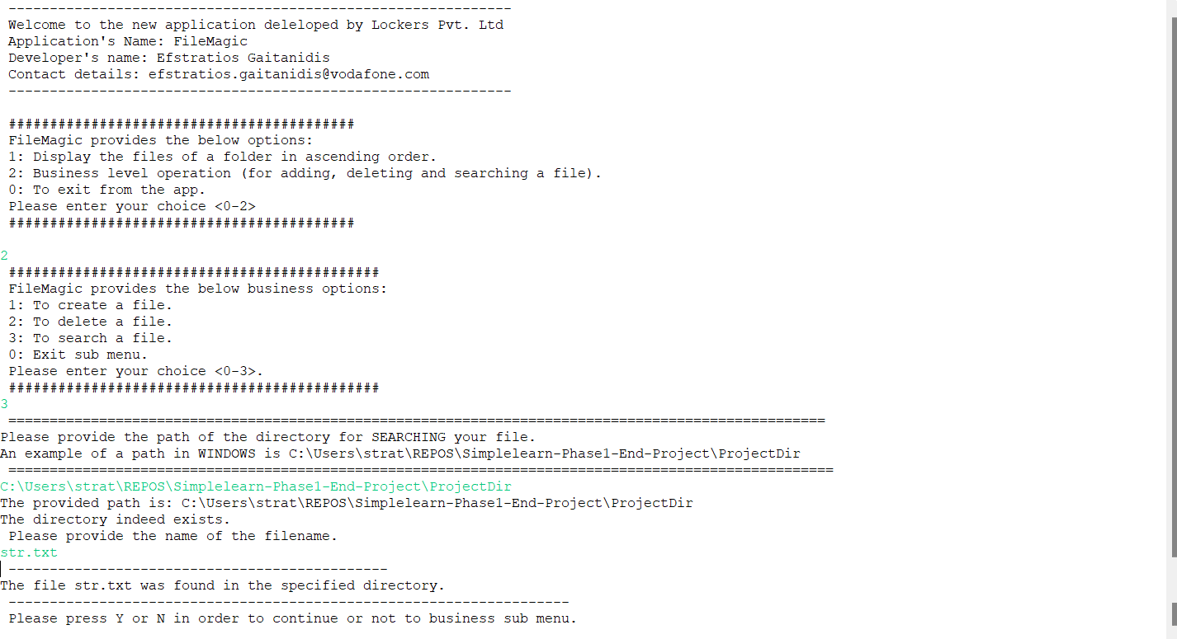

In this case the file was not found or user does not have the permissions.

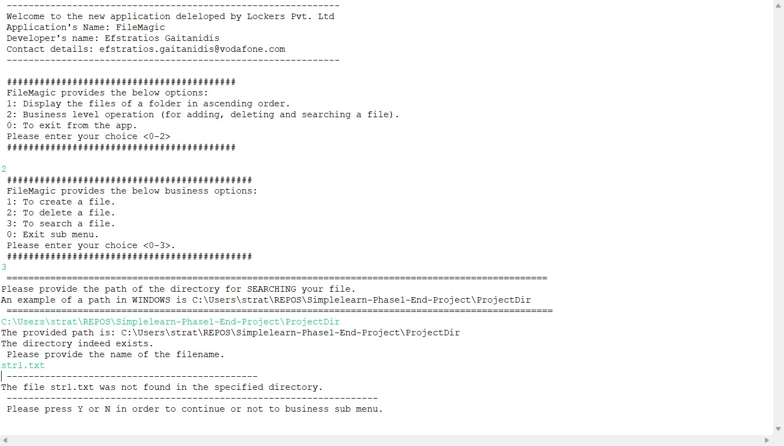

And here the user provided an incorrect directory path

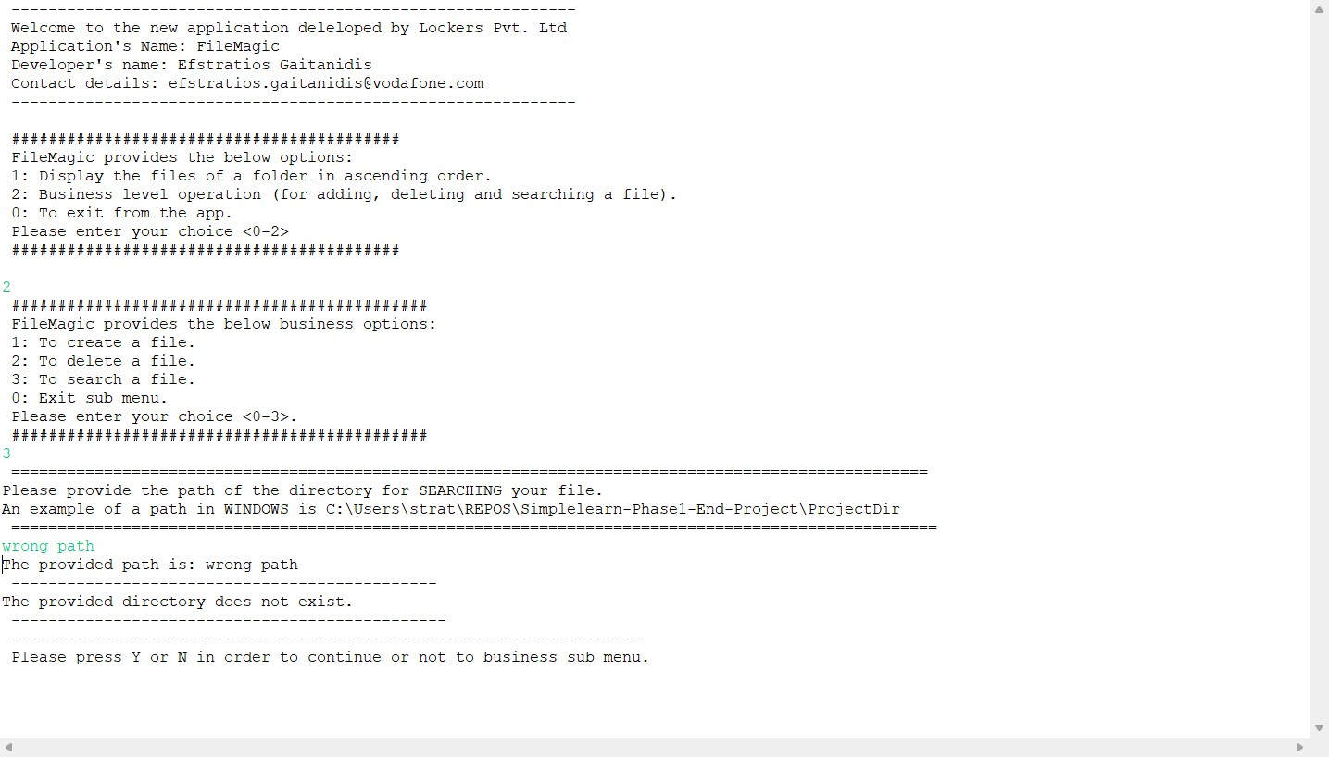

## Menus

User provided a wrong option in main menu (string or integer other than 0,1 and 2)

The App informs the user for the invalid option and ask him if he wants to stay in main menu

In this case the app will ask him if he wants to continue or not in main menu

User continued with Y and y

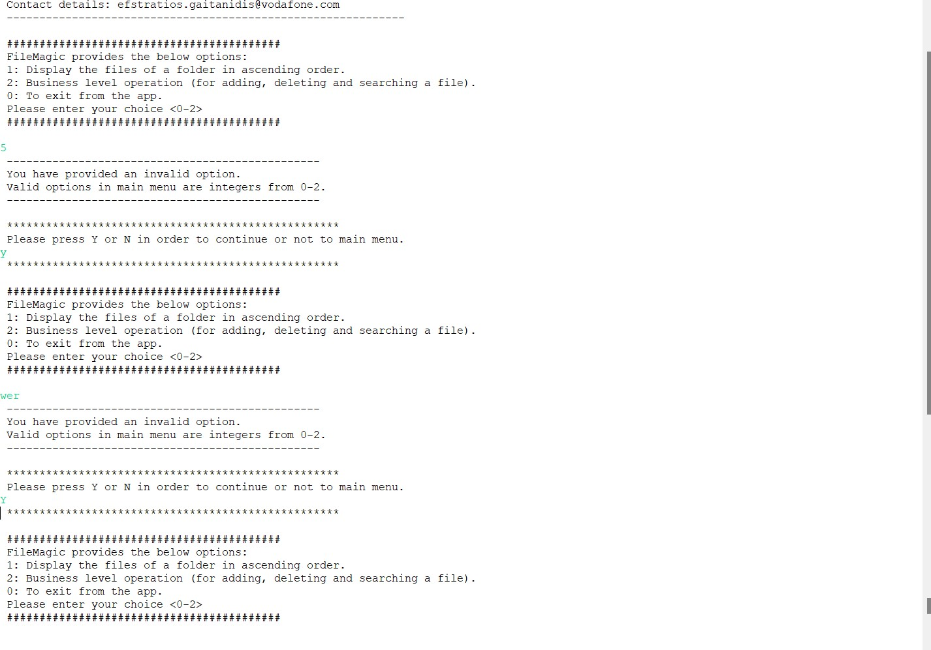

User provided an incorrect input in business menu.

For example, he entered a string or integer other than 3,2,1 and 0.

He continued with y and Y.

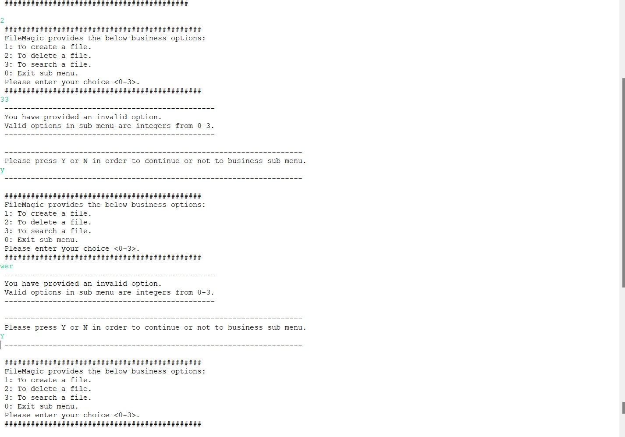

User can exit with 0 in main menu or press N/n when app asks user if he desires to continue or not.

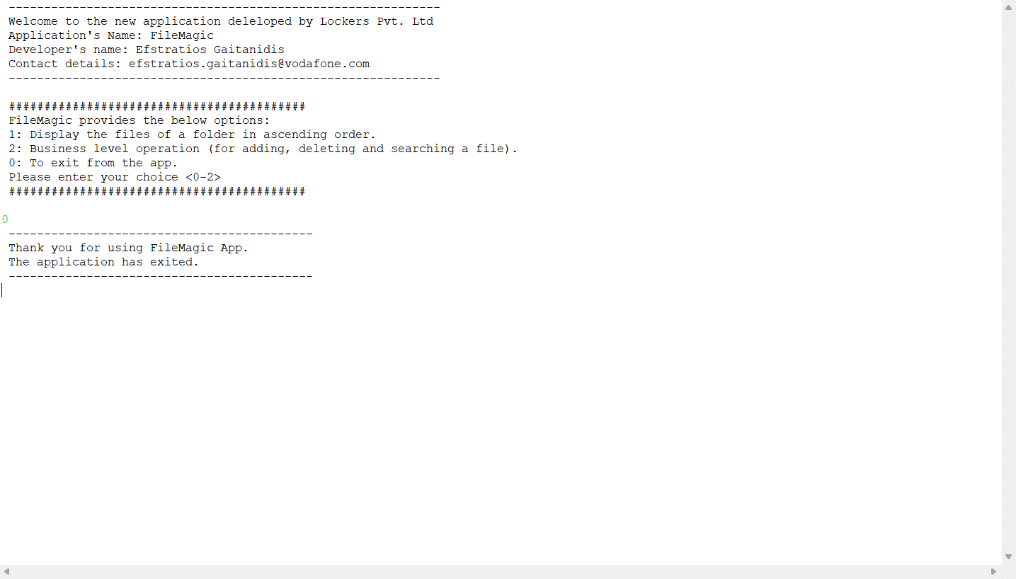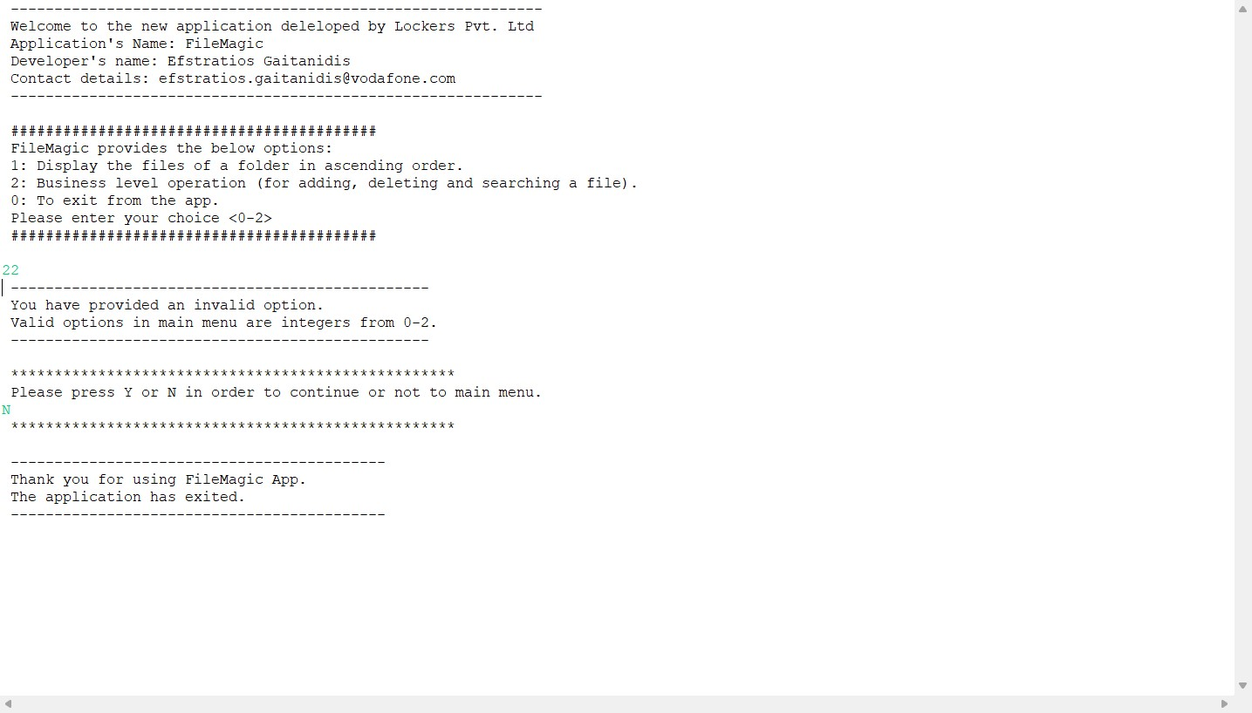

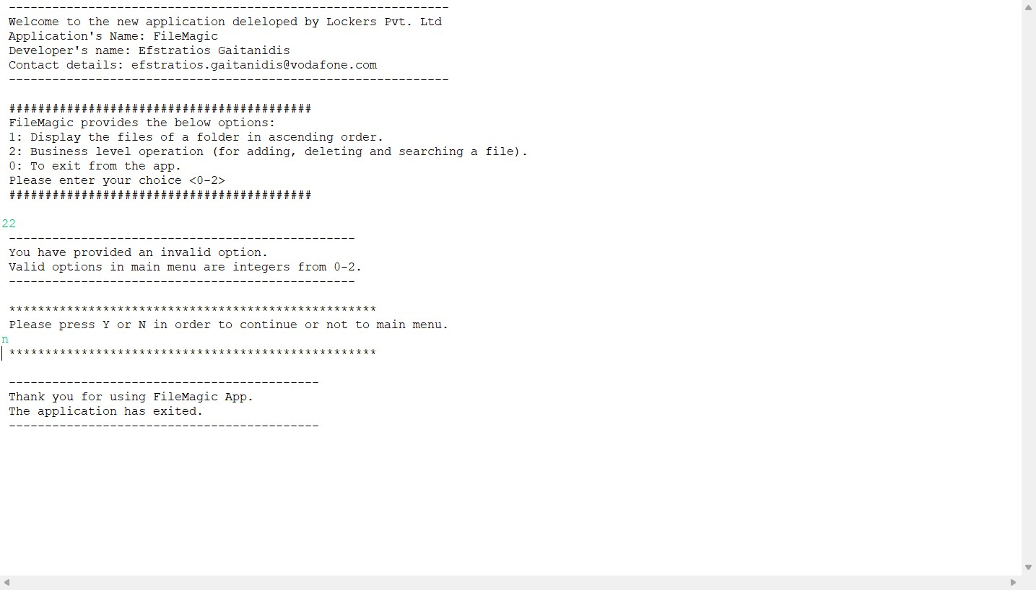

Similarly happens with submenu

With 0 the user exits to main menu and N/n when app asks user to continue or not in submenu (also known as business menu)

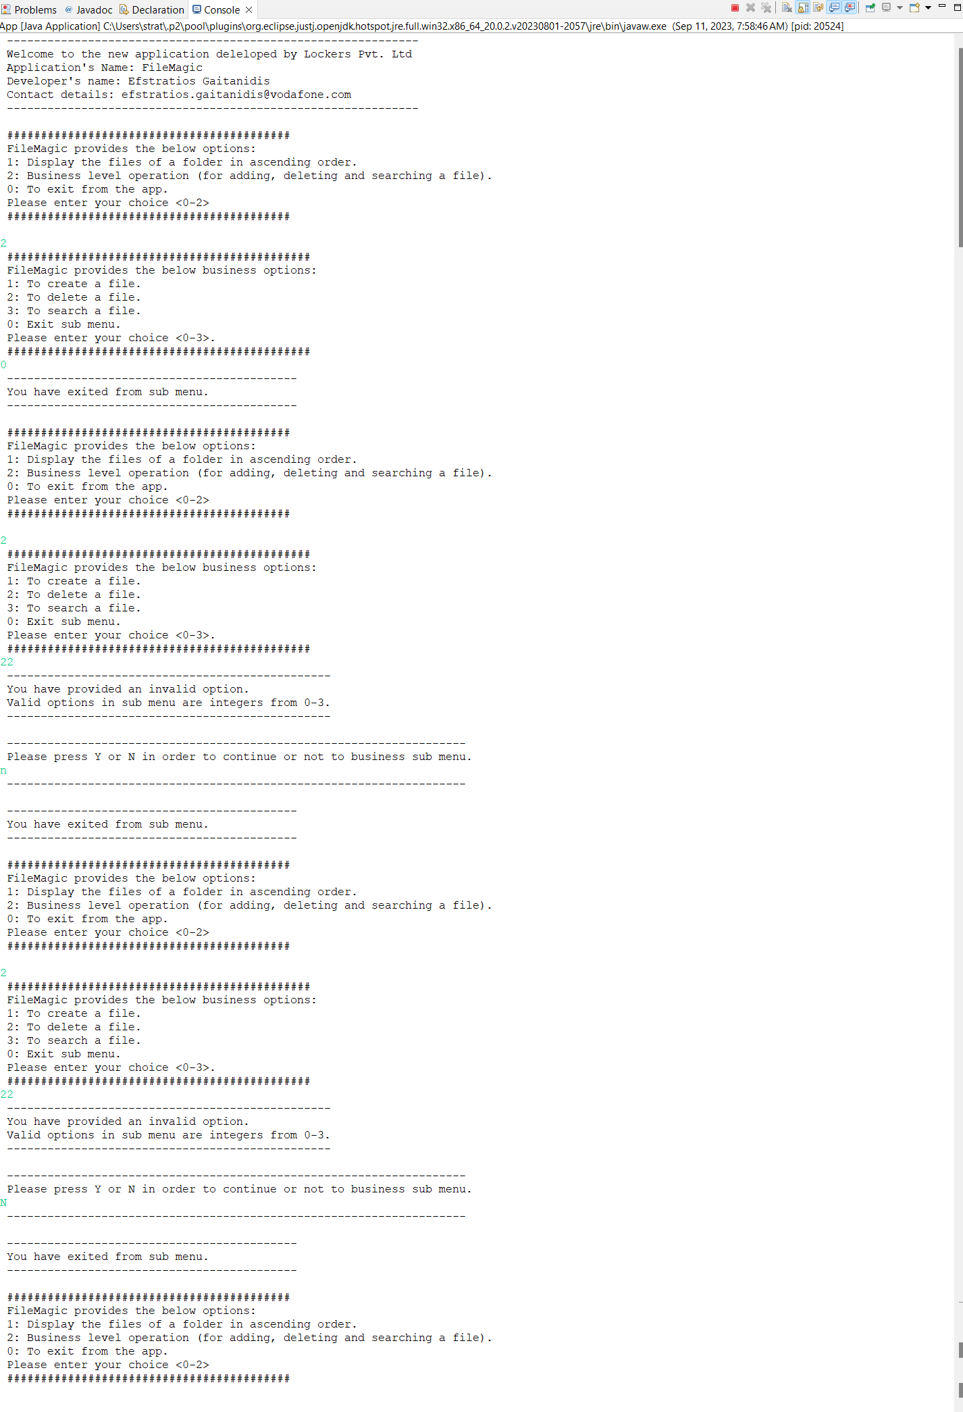

After the completion of an action, the app will ask in main menu and sub menu if user wants to continue or not. Valid inputs are: Y,y and N,n.

If user provides an invalid input, the app with present the appropriate message and user will remain in the menu

Invalid confirmation to continue in main menu

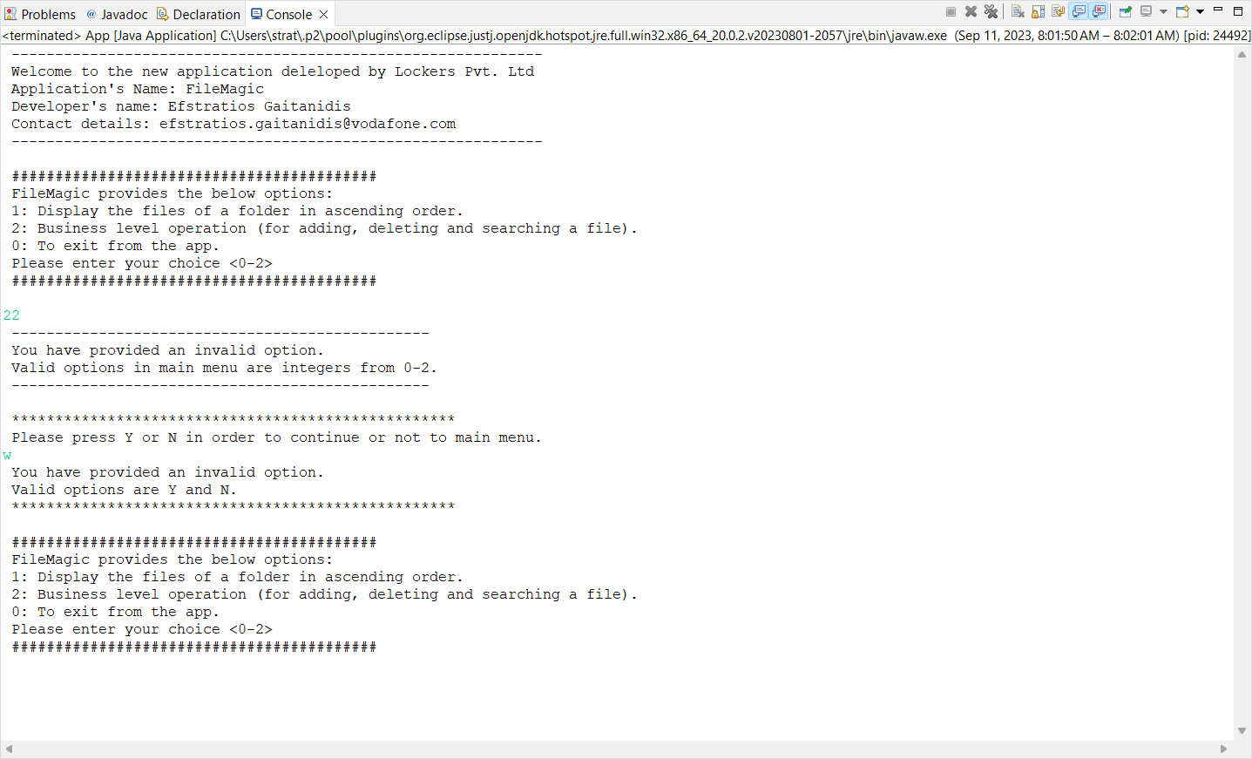

Invalid confirmation to continue in submenu



